CTM-I Use Case

Log Control

Version 0.1

Use Case Name | Log Control
Actor | App Support
Pre-conditions /Assumptions | User has Browser and is aware of the http path to the application.  User has successfully logged into the CTM-I application.  User has the right role to see the menu options.
Post Conditions | None
Screenshot | 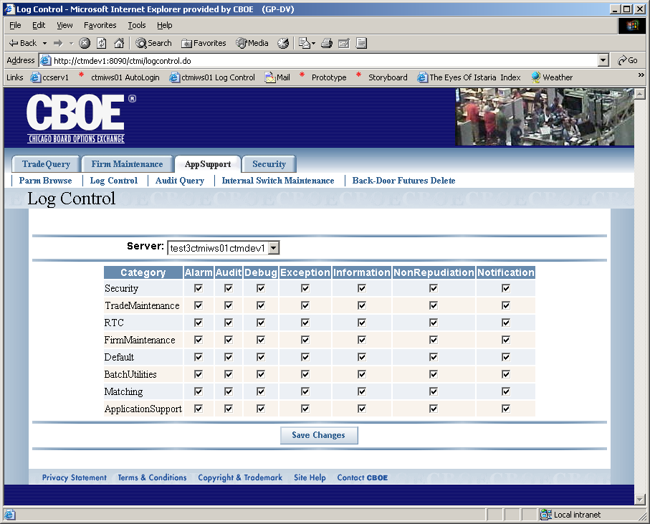
Flow of Events | - User selects “Log Control” from the menu.  - Log Control screen displays  - When the screen first appears, the user will only see the server selection. The server selection will display all of the integrated servers in the environment by Orbname.  - When the user selects a server to view, the screen will submit a request to get the log settings for that server. Once the settings are retrieved, the screen will display the settings.  - Log Settings will display in a table with each row representing a Category. Each category will have a name followed by the settings for that category for each logging level.  - The log categories are: Security, Trade Maintenance, RTC, Firm Maintenance, Default, Batch Utilities, Matching and Application Support.  - The log levels are: Alarm, Audit, Debug, Exception, Information, NonRepudiation and Notification.  - A check box will represent if the setting for the category and log level is on or off. The user will be allowed to change the setting by clicking the check box.  - Activating the “Save Changes” will send the changes to the application server. The application server will publish the changes to the appropriate server. The change should take affect immediately on the targeted server.  - After saving the changes, the screen will refresh with the latest settings for the server selected.
Alternative Path | - The initial configuration for the log settings is controlled by settings in the xml configuration file for the service.  - If at any time the user selects a different server from the server selection, the screen will immediately refresh with the settings for that server. All changes that have not been saved will be lost.

